**Step 1 :-**

Create a EC2 server

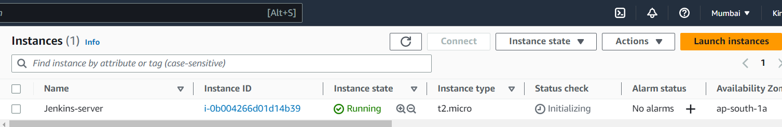

**Step 2:-**

Do SSH from local sys to EC2 and install the dependencies Java(openjdk-11-jdk) && install jenkins by referring official documents

**Step 3:-**

Check the status of jenkins by “**Sudo systemctl status jenkins**”

**Step 4 :-**

If status shows active(running) we can go ahead directly with **step 5**, else enable & start the the jenkins service by using below following commands

**Sudo systemctl enable jenkins**

**Sudo systemctl start jenkins**

**Step 5 :-**

Enter a public IP and followed by jenkins port number(8080) in URL and press ENTER and login

Please note : enable 8080 port from SG in EC2 server

**Step 6 :-**

Take a initial password from following path by using below command in shell and enter the initial password from jenkins server

**cat /var/lib/jenkins/secrets/initialAdminPassword**

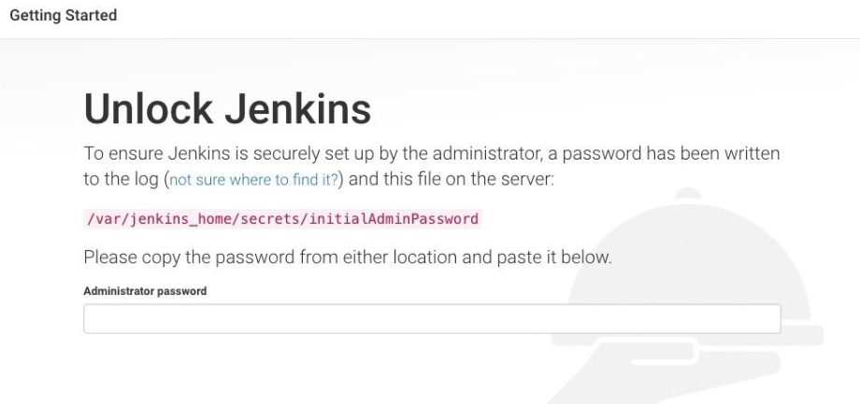

**Step 7:-** Enter the admin/user credentials & once done it will shows as below screenshot

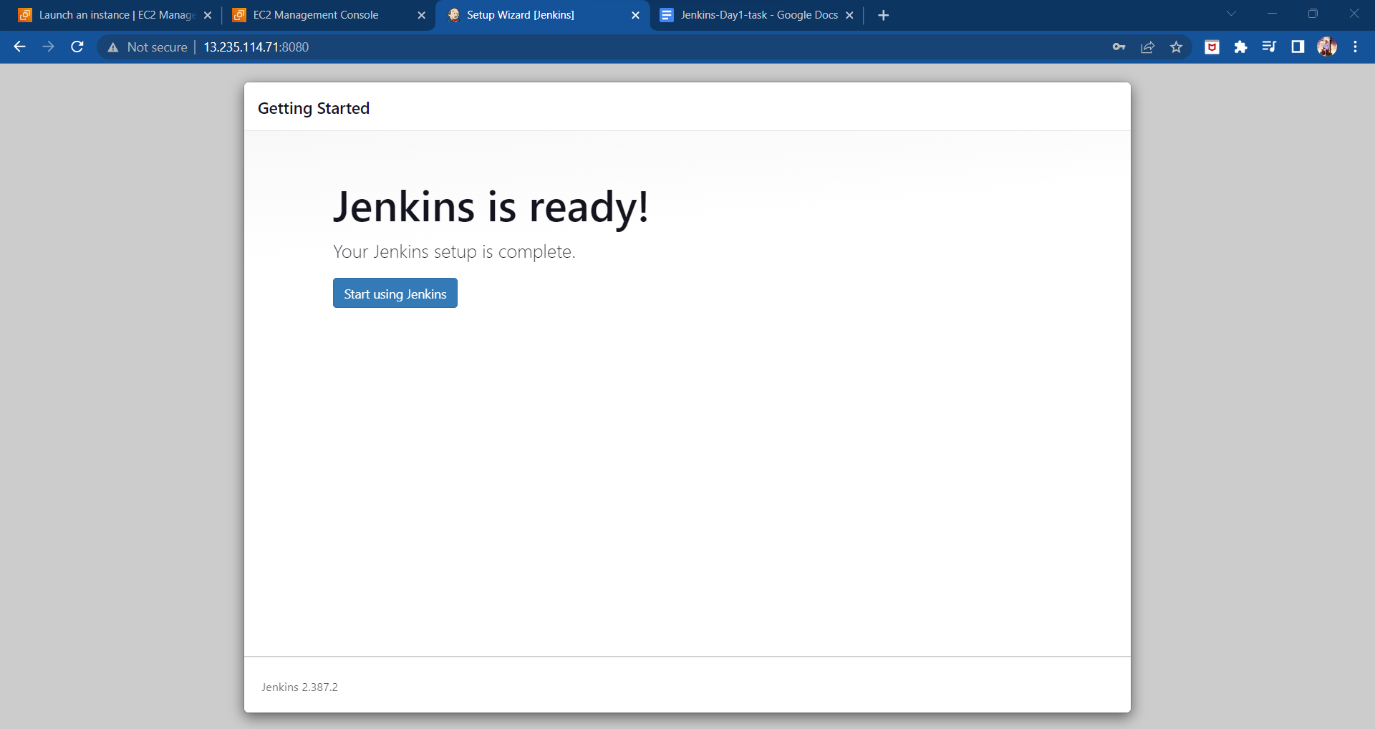

**Step 8 :-**

Create a first job - freestyle

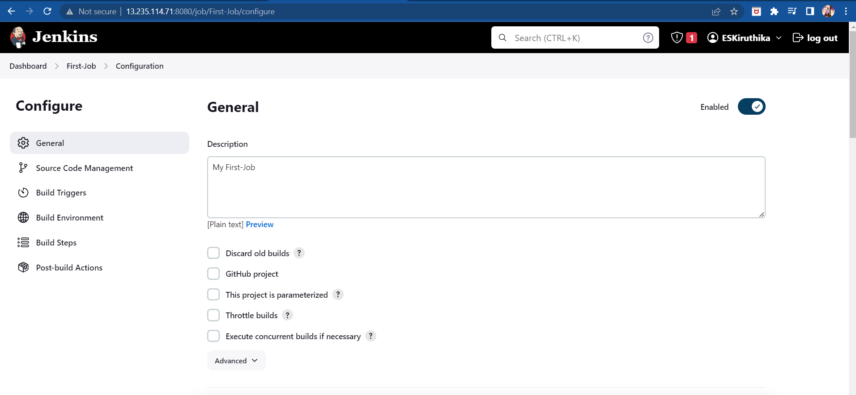

**Step 9:-** Enter the Github cloning repo ID into jenkins (as per below screenshot)

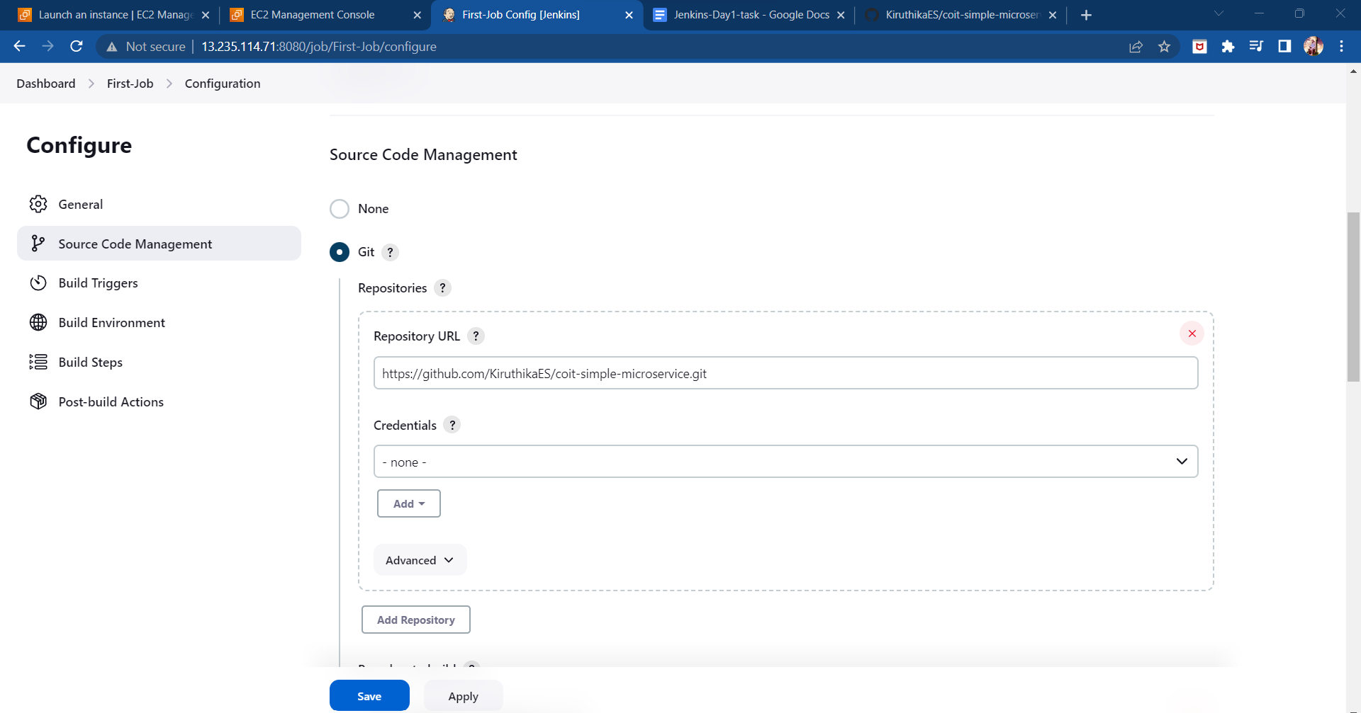

**Step 10 :-**

Refer Branch name in Github

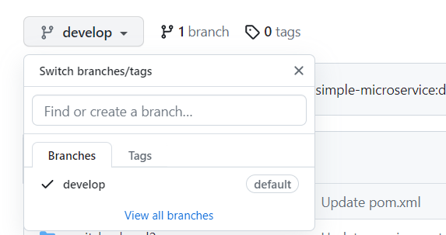

**Step 11:-**

Enter the branch name in Jenkins server

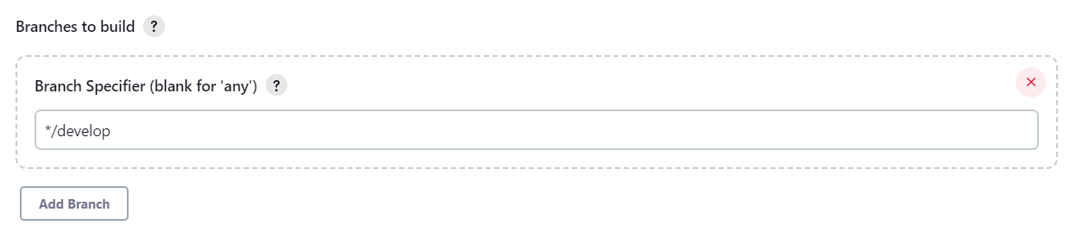

**Step 12:-** Enter the shell commands in build steps and once done click on save & apply

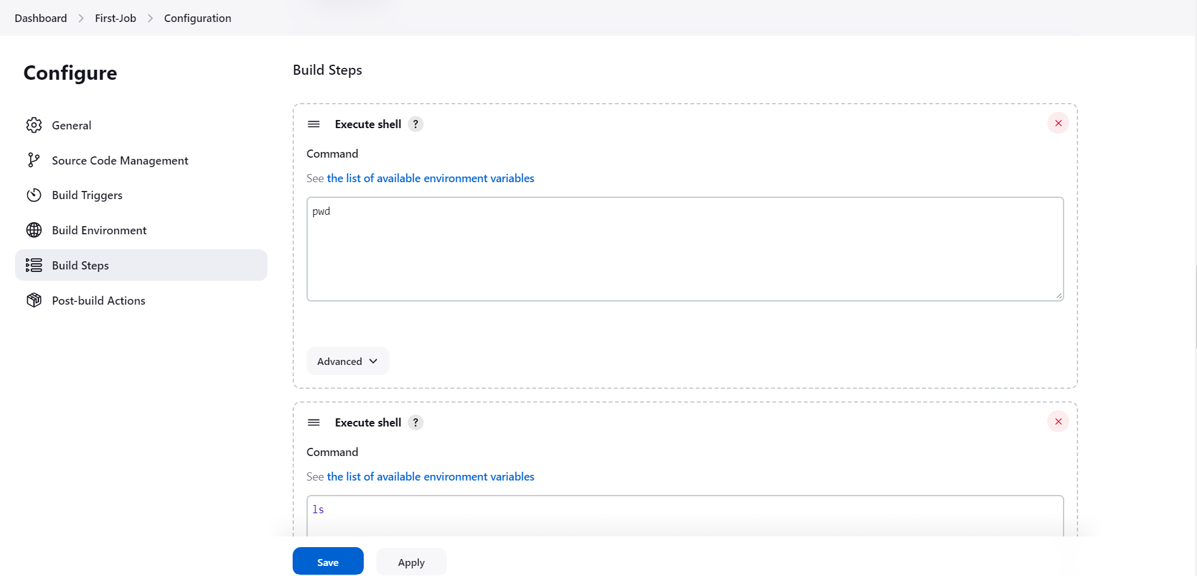

Step 13 :- Then click on “**Build Now**”

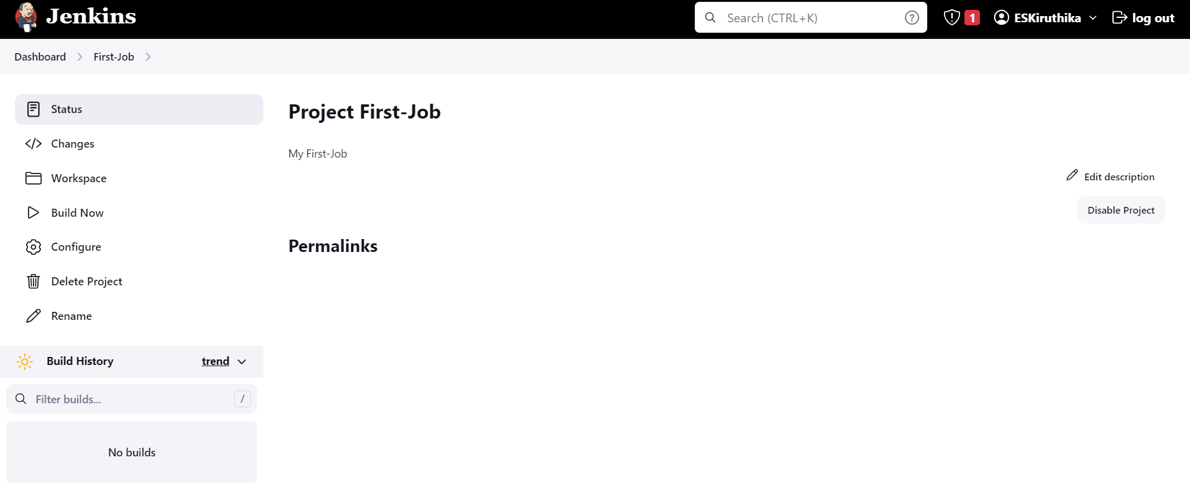

**Step 14 :-**

Once build complete its status reflects below build history

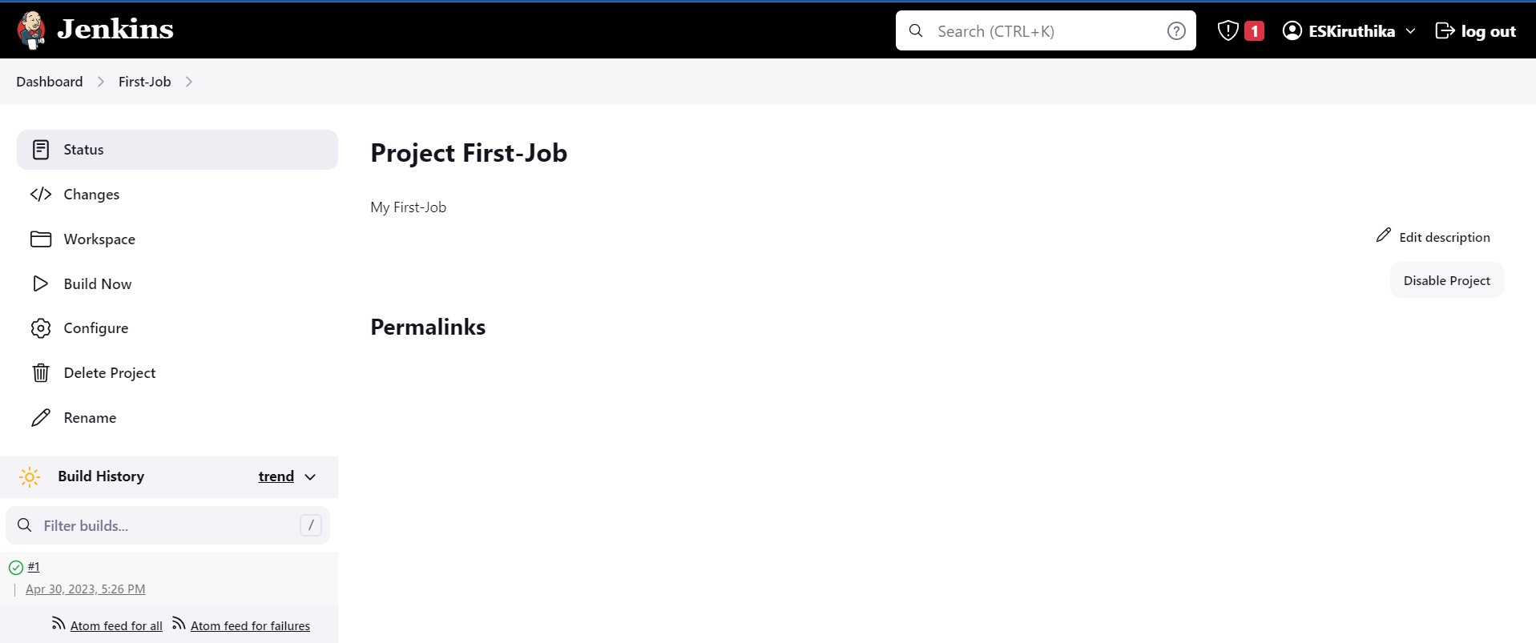

**Step 15 :-**

Below is the status of Build

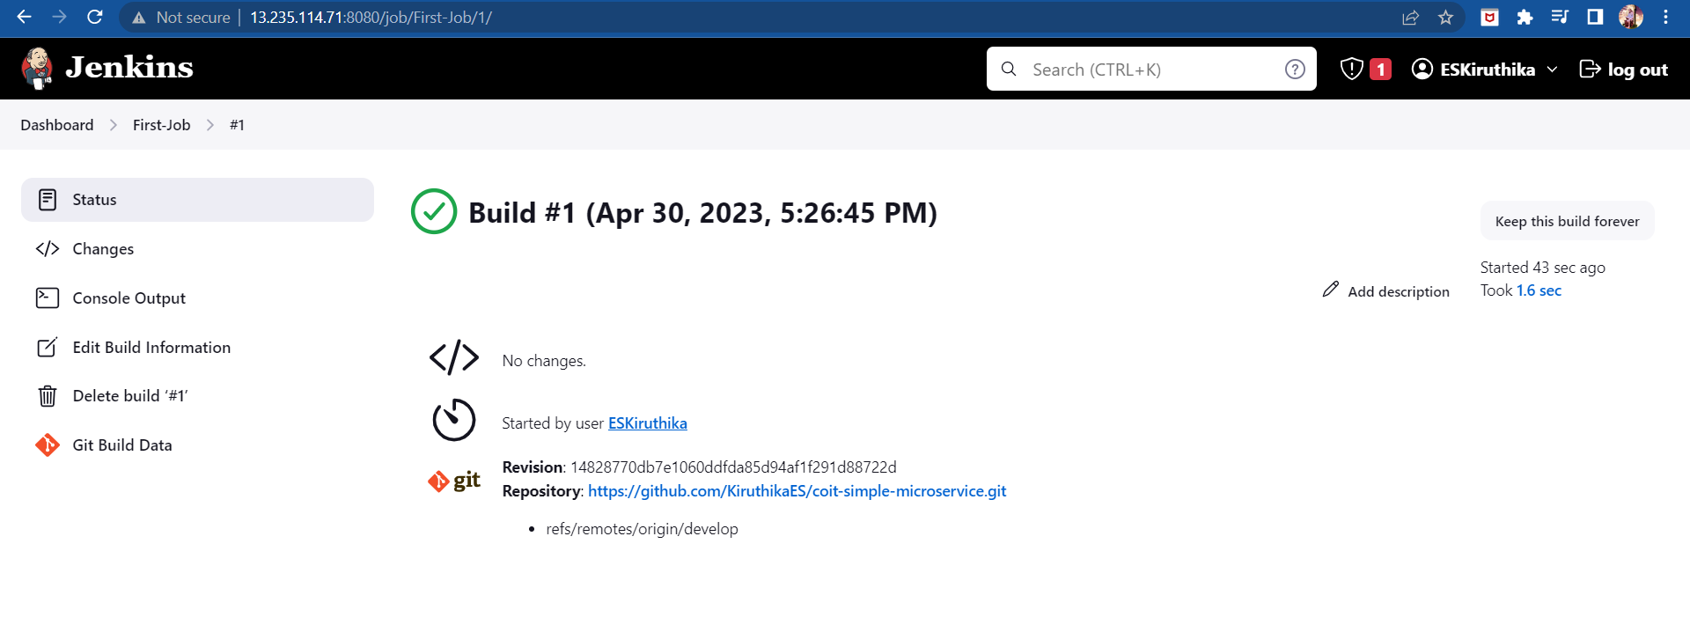**Step 16 :-** click on console output to see detailed output

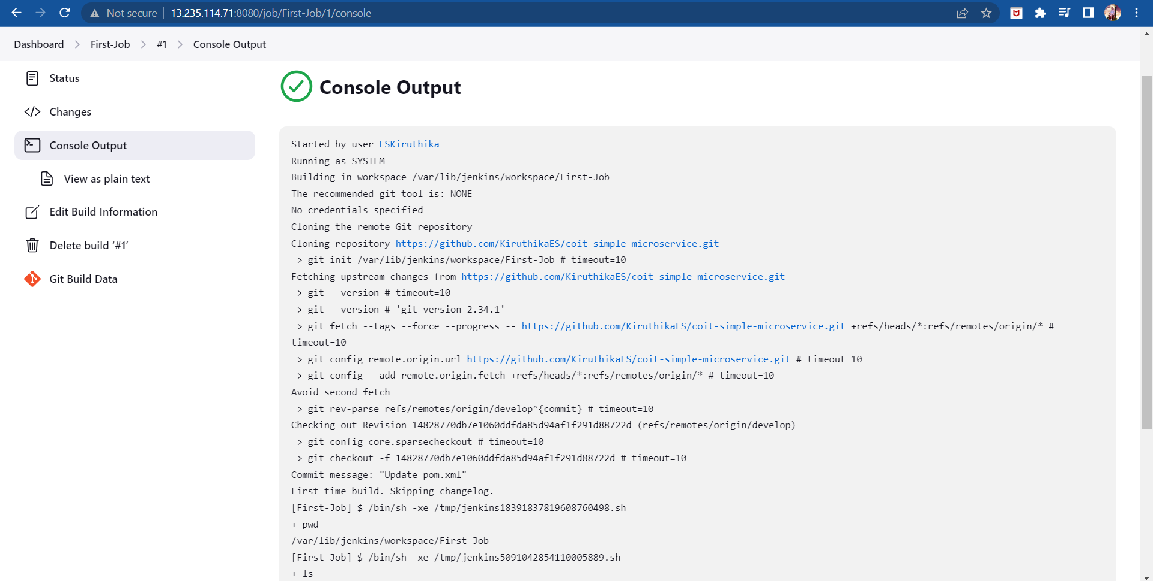

**Step 17 :-** Cross with EC2 server whether all files copied as per the branch.

